**Operating System Properties**

## Batch processing

Batch processing is a technique in which an Operating System collects the programs and data together in a batch before processing starts. An operating system does the following activities related to batch processing −

* The OS defines a job which has predefined sequence of commands, programs and data as a single unit.
* The OS keeps a number a jobs in memory and executes them without any manual information.
* Jobs are processed in the order of submission, i.e., first come first served fashion.
* When a job completes its execution, its memory is released and the output for the job gets copied into an output spool for later printing or processing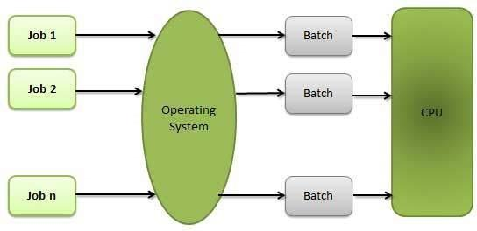.

### Advantages

* Batch processing takes much of the work of the operator to the computer.
* Increased performance as a new job get started as soon as the previous job is finished, without any manual intervention.

### Disadvantages

* Difficult to debug program.
* A job could enter an infinite loop.
* Due to lack of protection scheme, one batch job can affect pending jobs.

## Multitasking

Multitasking is when multiple jobs are executed by the CPU simultaneously by switching between them. Switches occur so frequently that the users may interact with each program while it is running. An OS does the following activities related to multitasking −

* The user gives instructions to the operating system or to a program directly, and receives an immediate response.
* The OS handles multitasking in the way that it can handle multiple operations/executes multiple programs at a time.
* Multitasking Operating Systems are also known as Time-sharing systems.
* These Operating Systems were developed to provide interactive use of a computer system at a reasonable cost.
* A time-shared operating system uses the concept of CPU scheduling and multiprogramming to provide each user with a small portion of a time-shared CPU.
* Each user has at least one separate program in memory.

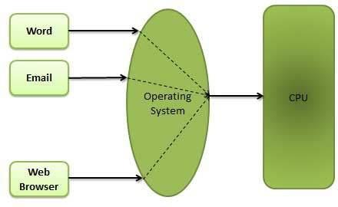

* A program that is loaded into memory and is executing is commonly referred to as a **process**.
* When a process executes, it typically executes for only a very short time before it either finishes or needs to perform I/O.
* Since interactive I/O typically runs at slower speeds, it may take a long time to complete. During this time, a CPU can be utilized by another process.
* The operating system allows the users to share the computer simultaneously. Since each action or command in a time-shared system tends to be short, only a little CPU time is needed for each user.
* As the system switches CPU rapidly from one user/program to the next, each user is given the impression that he/she has his/her own CPU, whereas actually one CPU is being shared among many users.

## Multiprogramming

Sharing the processor, when two or more programs reside in memory at the same time, is referred as **multiprogramming**. Multiprogramming assumes a single shared processor. Multiprogramming increases CPU utilization by organizing jobs so that the CPU always has one to execute.

The following figure shows the memory layout for a multiprogramming system.

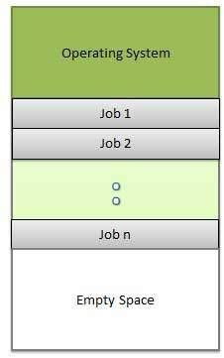

An OS does the following activities related to multiprogramming.

* The operating system keeps several jobs in memory at a time.
* This set of jobs is a subset of the jobs kept in the job pool.
* The operating system picks and begins to execute one of the jobs in the memory.
* Multiprogramming operating systems monitor the state of all active programs and system resources using memory management programs to ensures that the CPU is never idle, unless there are no jobs to process.

### Advantages

* High and efficient CPU utilization.
* User feels that many programs are allotted CPU almost simultaneously.

### Disadvantages

* CPU scheduling is required.
* To accommodate many jobs in memory, memory management is required.

## Interactivity

Interactivity refers to the ability of users to interact with a computer system. An Operating system does the following activities related to interactivity −

* Provides the user an interface to interact with the system.
* Manages input devices to take inputs from the user. For example, keyboard.
* Manages output devices to show outputs to the user. For example, Monitor.

The response time of the OS needs to be short, since the user submits and waits for the result.

## Real Time System

Real-time systems are usually dedicated, embedded systems. An operating system does the following activities related to real-time system activity.

* In such systems, Operating Systems typically read from and react to sensor data.
* The Operating system must guarantee response to events within fixed periods of time to ensure correct performance.

## Distributed Environment

A distributed environment refers to multiple independent CPUs or processors in a computer system. An operating system does the following activities related to distributed environment −

* The OS distributes computation logics among several physical processors.
* The processors do not share memory or a clock. Instead, each processor has its own local memory.
* The OS manages the communications between the processors. They communicate with each other through various communication lines.

## Spooling

Spooling is an acronym for simultaneous peripheral operations on line. Spooling refers to putting data of various I/O jobs in a buffer. This buffer is a special area in memory or hard disk which is accessible to I/O devices.

An operating system does the following activities related to distributed environment −

* Handles I/O device data spooling as devices have different data access rates.
* Maintains the spooling buffer which provides a waiting station where data can rest while the slower device catches up.
* Maintains parallel computation because of spooling process as a computer can perform I/O in parallel fashion. It becomes possible to have the computer read data from a tape, write data to disk and to write out to a tape printer while it is doing its computing task.

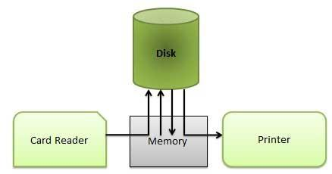

### Advantages

* The spooling operation uses a disk as a very large buffer.
* Spooling is capable of overlapping I/O operation for one job with processor operations for another job.

Based on the above properties we have various types of OS which are as follows:

**Types of Operating System**

Simple Batch Systems

Jobs were submitted on cards or tape to an operator who batches jobs together sequentially. The program that controls the execution of the jobs was called **monitor** - a simple version of an operating system. The interface to the monitor was accomplished through Job Control Language (JCL). For example, a JCL request could be to run the compiler for a particular programming language, then to link and load the program, then to run the user program.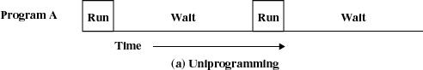

**Problems:**

Bad utilization of CPU time - the processor stays idle while I/O devices are in use.

**Multiprogrammed Batch Systems**

More than one program resides in the main memory. While a program A uses an I/O device the processor does not stay idle, instead it runs another program B.

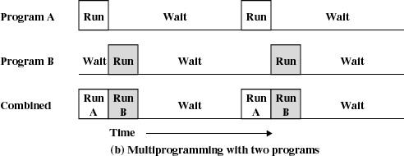

**New features**:

Memory management - to have several jobs ready to run, they must be kept in main memory

Job scheduling - the processor must decide which program to run.

Time-sharing operating systems

Time-sharing is a technique which enables many people, located at various terminals, to use a particular computer system at the same time. Time-sharing or multitasking is a logical extension of multiprogramming. Processor's time which is shared among multiple users simultaneously is termed as time-sharing.

The main difference between Multiprogrammed Batch Systems and Time-Sharing Systems is that in case of Multiprogrammed batch systems the objective is to maximize processor use, whereas in Time-Sharing Systems the objective is to minimize response time.

Multiple jobs are executed by the CPU by switching between them, but the switches occur so frequently. Thus, the user can receive an immediate response. For example, in a transaction processing, the processor executes each user program in a short burst or quantum of computation. That is, if **n** users are present, then each user can get a time quantum. When the user submits the command, the response time is in few seconds at most.

The operating system uses CPU scheduling and multiprogramming to provide each user with a small portion of a time. Computer systems that were designed primarily as batch systems have been modified to time-sharing systems.

**Advantages of Timesharing operating systems are as follows −**

* Provides the advantage of quick response.
* Avoids duplication of software.
* Reduces CPU idle time.

**Disadvantages of Time-sharing operating systems are as follows −**

* Problem of reliability.
* Question of security and integrity of user programs and data.
* Problem of data communication.

Distributed operating System

Distributed systems use multiple central processors to serve multiple real-time applications and multiple users. Data processing jobs are distributed among the processors accordingly.

The processors communicate with one another through various communication lines (such as high-speed buses or telephone lines). These are referred as **loosely coupled systems** or distributed systems. Processors in a distributed system may vary in size and function. These processors are referred as sites, nodes, computers, and so on.

The advantages of distributed systems are as follows −

* With resource sharing facility, a user at one site may be able to use the resources available at another.
* Speedup the exchange of data with one another via electronic mail.
* If one site fails in a distributed system, the remaining sites can potentially continue operating.
* Better service to the customers.
* Reduction of the load on the host computer.
* Reduction of delays in data processing.

## Network operating System

A Network Operating System runs on a server and provides the server the capability to manage data, users, groups, security, applications, and other networking functions. The primary purpose of the network operating system is to allow shared file and printer access among multiple computers in a network, typically a local area network (LAN), a private network or to other networks.

Examples of network operating systems include Microsoft Windows Server 2003, Microsoft Windows Server 2008, UNIX, Linux, Mac OS X, Novell NetWare, and BSD.

The advantages of network operating systems are as follows −

* Centralized servers are highly stable.
* Security is server managed.
* Upgrades to new technologies and hardware can be easily integrated into the system.
* Remote access to servers is possible from different locations and types of systems.

The disadvantages of network operating systems are as follows −

* High cost of buying and running a server.
* Dependency on a central location for most operations.
* Regular maintenance and updates are required.

## Real Time operating System

A real-time system is defined as a data processing system in which the time interval required to process and respond to inputs is so small that it controls the environment. The time taken by the system to respond to an input and display of required updated information is termed as the **response time**. So in this method, the response time is very less as compared to online processing.

Real-time systems are used when there are rigid time requirements on the operation of a processor or the flow of data and real-time systems can be used as a control device in a dedicated application. A real-time operating system must have well-defined, fixed time constraints, otherwise the system will fail. For example, scientific experiments, medical imaging systems, industrial control systems, weapon systems, robots, air traffic control systems, etc.

There are two types of real-time operating systems.

### Hard real-time systems

Hard real-time systems guarantee that critical tasks complete on time. In hard real-time systems, secondary storage is limited or missing and the data is stored in ROM. In these systems, virtual memory is almost never found.

### Soft real-time systems

Soft real-time systems are less restrictive. A critical real-time task gets priority over other tasks and retains the priority until it completes. Soft real-time systems have limited utility than hard real-time systems. For example, multimedia, virtual reality, Advanced Scientific Projects like undersea exploration and planetary rovers, etc.

**OS Examples:**

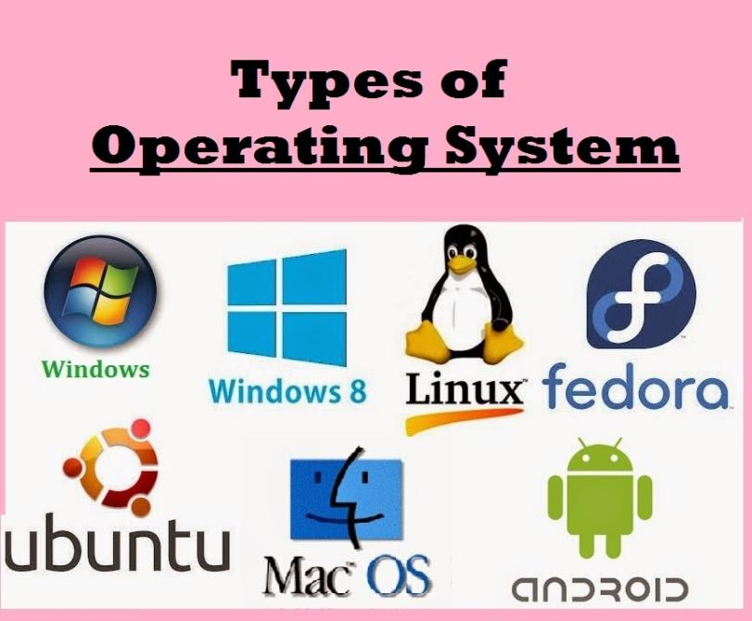

Video Links: <https://www.youtube.com/watch?v=TQWERtMoKbI&list=PLBlnK6fEyqRiVhbXDGLXDk_OQAeuVcp2O&index=7>

<https://www.youtube.com/watch?v=fvN98a_7AT4&list=PLBlnK6fEyqRiVhbXDGLXDk_OQAeuVcp2O&index=6>

REFERENCES:

1. Galvin, Peter B., Silberchatz, A., “*Operating System Concepts*”, Addison Wesley, 8th Edition.
2. Flynn, *“Operating Systems”*, Cengage Learning.
3. Dhamdhere, D.M., "*Operating System:A Concept Based Approach*",  
   Tata Mc-Graw- Hill.
4. **https://www.youtube.com/watch?v=MR2ntdZW__A**
5. <https://www.digimat.in/nptel/courses/video/106106144/L03.html>
6. <https://computing.llnl.gov/tutorials/>
7. <https://nptel.ac.in/courses/106/105/106105214/>
8. <https://www.guru99.com/operating-system-tutorial.html>
9. <https://www.geeksforgeeks.org/operating-systems/>